Hands-on Exercise No. 1 — Solution
DigiSkills 3.0 Batch-04 | Full Stack Development with MERN
Student: Ghazanfar Ali
This document provides the required Personal Profile Web Page solution, source code, browser output and Git workflow evidence.

Question 1: Personal Profile Web Page

Part 1: HTML structure (3 Marks)
The page has a descriptive title, name heading, About Me paragraphs, Skills list and an email contact link. Save the following file as index.html.
<!DOCTYPE html>
<html lang="en">
<head>
<meta charset="UTF-8">
<meta name="viewport" content="width=device-width, initial-scale=1.0">
<title>Ghazanfar Ali | Personal Profile</title>
<link rel="stylesheet" href="style.css">
</head>
<body>
<main class="profile-card">
<header class="profile-header">
<h1>Ghazanfar Ali</h1>
<p class="tagline">Full Stack Developer | React &amp; MERN</p>
</header>
<section>
<h2>About Me</h2>
<p>I am a Full Stack Developer interested in building modern, responsive and user-friendly web applications. I enjoy solving development problems and continuously improving my programming skills.</p>
<p>My current focus is JavaScript-based development, particularly React, Node.js and modern web technologies.</p>
</section>
<section>
<h2>Skills</h2>
<ul>
<li>HTML5 &amp; CSS3</li>
<li>JavaScript</li>
<li>React.js</li>
<li>Node.js &amp; Express.js</li>
<li>MongoDB</li>
<li>Git &amp; GitHub</li>
</ul>
</section>
<section>
<h2>Contact</h2>
<p>Email: <a href="mailto:ghazanfarali4994@gmail.com">ghazanfarali4994@gmail.com</a></p>
<p>GitHub: <a href="https://github.com/GhazanfarAliTech" target="_blank" rel="noopener">github.com/GhazanfarAliTech</a></p>
</section>
</main>
</body>
</html>
Screenshot — HTML code:
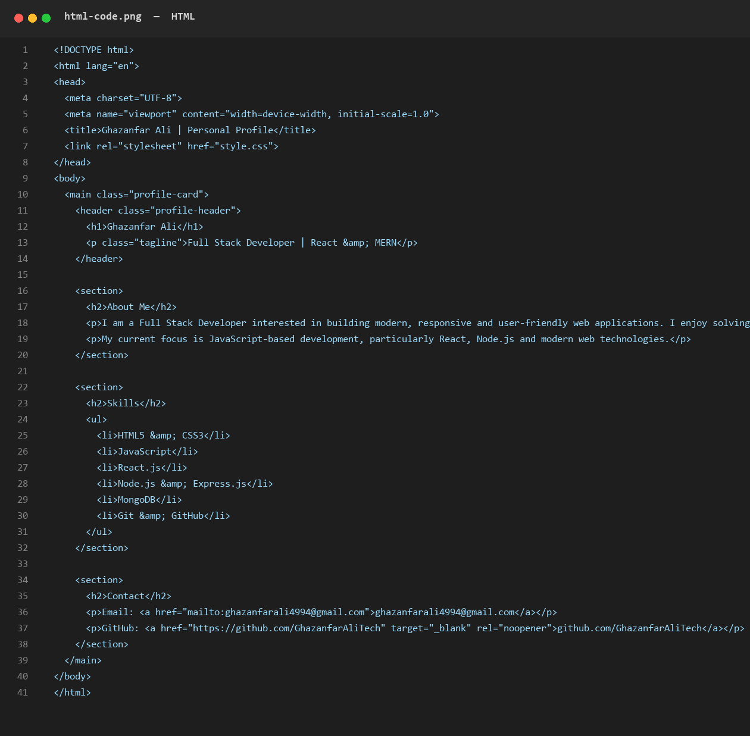
Screenshot — HTML-only browser output (before applying style.css):
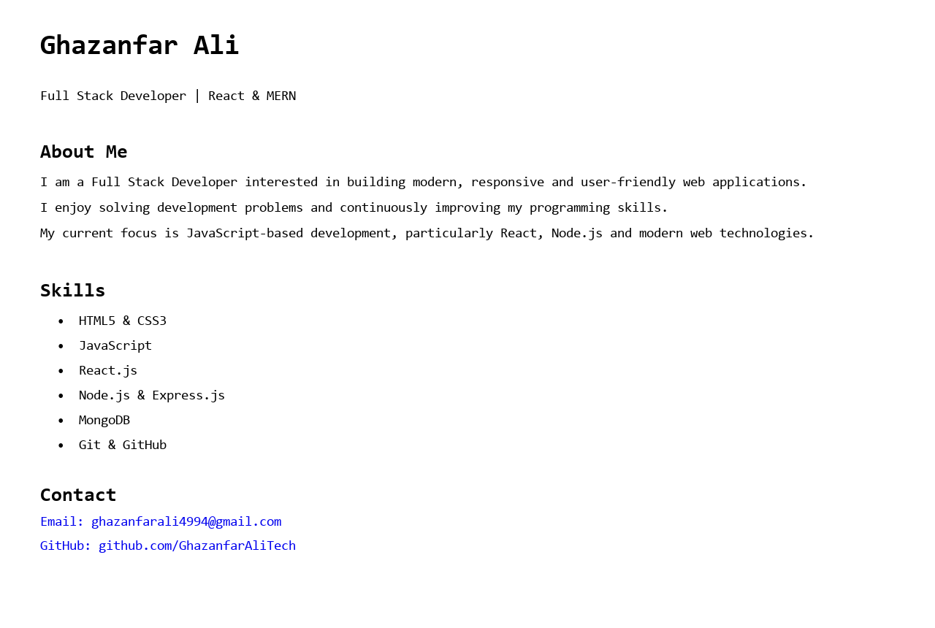

Part 2: CSS styling and responsive layout (2 Marks)
The following CSS adds colors, spacing, borders, font styling, a centered card layout and a mobile media query. Save it as style.css in the same folder.
* {
box-sizing: border-box;
margin: 0;
padding: 0;
}
body {
font-family: Arial, sans-serif;
background: #f3f4f6;
color: #1f2937;
line-height: 1.6;
padding: 30px 15px;
}
.profile-card {
width: min(100%, 760px);
margin: 0 auto;
background: #ffffff;
border: 1px solid #d1d5db;
border-radius: 16px;
padding: 32px;
box-shadow: 0 8px 24px rgba(0, 0, 0, 0.08);
}
.profile-header {
text-align: center;
border-bottom: 1px solid #e5e7eb;
padding-bottom: 24px;
margin-bottom: 24px;
}
h1 { font-size: 2.2rem; margin-bottom: 6px; }
.tagline { color: #4b5563; font-weight: 600; }
section { margin-bottom: 24px; }
h2 { font-size: 1.35rem; margin-bottom: 10px; }
p { margin-bottom: 10px; }
ul { padding-left: 24px; }
li { margin-bottom: 6px; }
a { color: #2563eb; font-weight: 600; }
@media (max-width: 600px) {
body { padding: 15px 10px; }
.profile-card { padding: 22px 18px; border-radius: 12px; }
h1 { font-size: 1.8rem; }
}
Screenshot — CSS code:
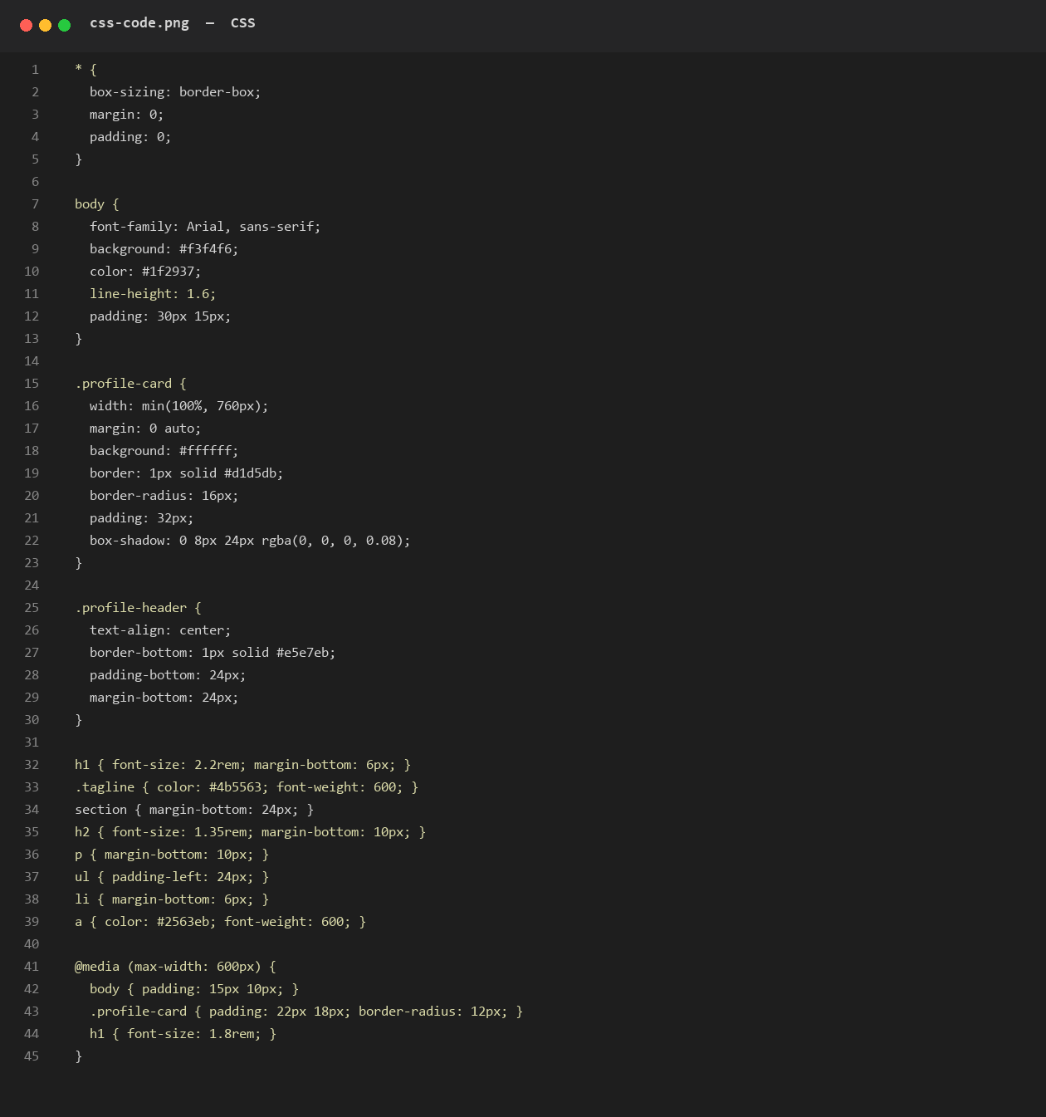
Screenshot — final styled browser output:
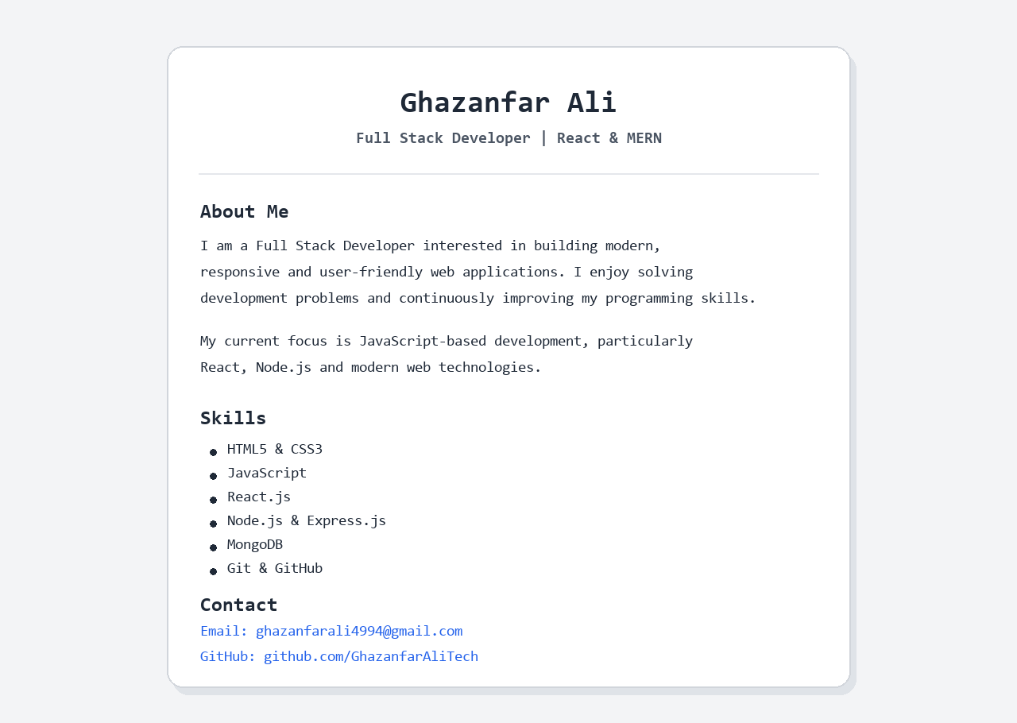

Question 2: Git Repository and Upload

Part 1: Initialize the repository (2 Marks)
Open a terminal in the personal-profile folder and run:
git init
git status

Part 2: Add, commit, connect and upload (3 Marks)
Use the following commands to upload the project to the supplied GitHub repository:
git add .
git commit -m "Create personal profile web page"
git branch -M main
git remote add origin https://github.com/GhazanfarAliTech/digi_skills.git
git push -u origin main
Screenshot — local Git initialization, add, commit and clean status:
